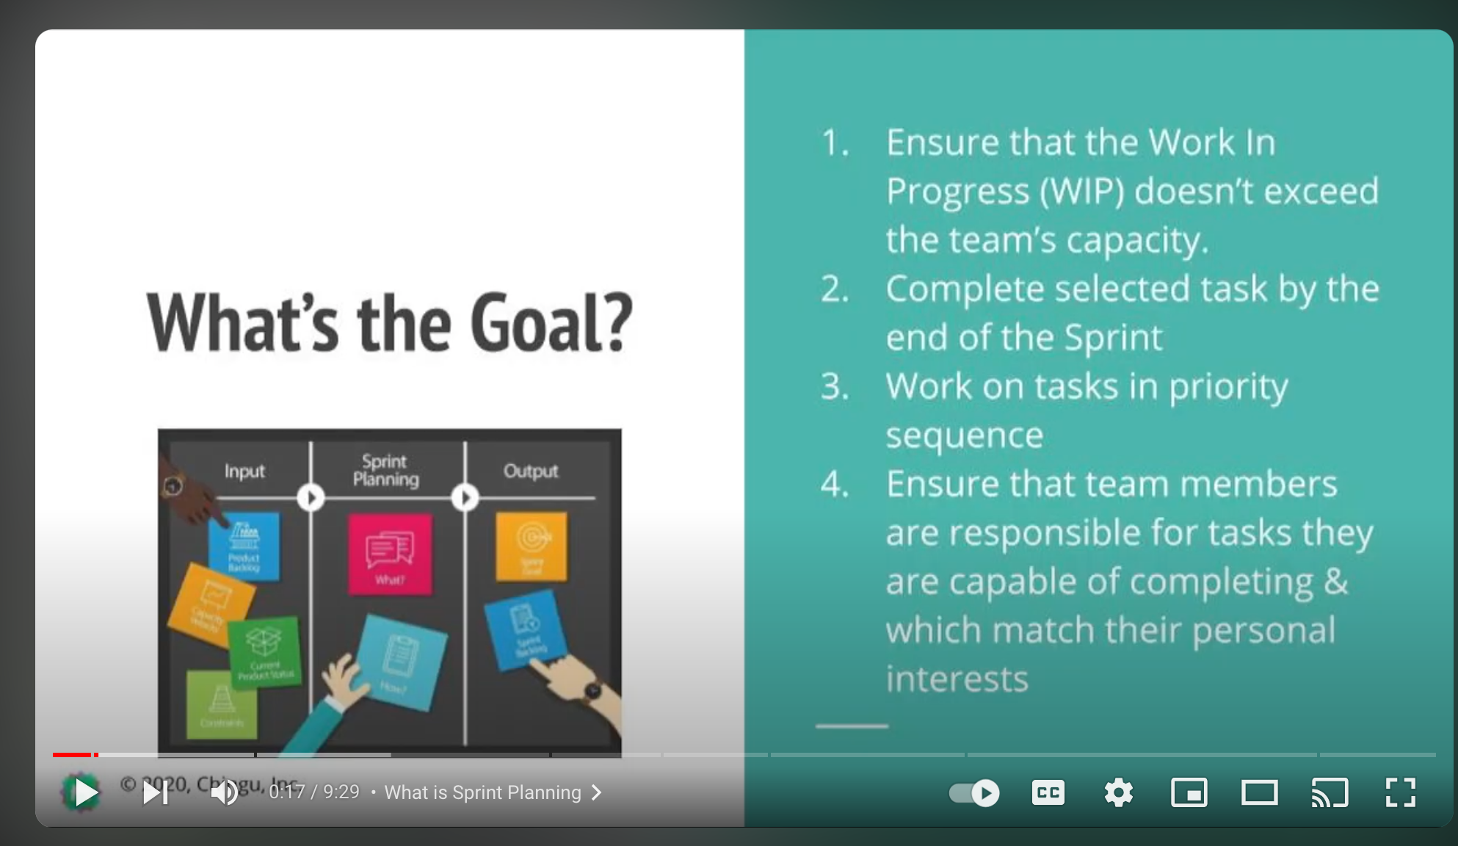

**Stakeholders**- anyone who has an interest in projects success

**Velocity**- rate at which the team works

**Constraints**-things that slow down a teams velocity ex-task complexity, schedule conflicts

**Storypoints**- way to estimate relative difficulty of given task ex-team members give a Fibonacci number* value to how difficult they think it is

**Work in Progress-** amount of work in progress measured by sum of storypoint numbers of active tasks

**Early and continuous delivery**- tasks completed in sprint must be deployed at end of sprint

*Fibonacci numbers are numbers in a sequence where a number is the sum of the two numbers that precede it. Ex- 0, 1, 1, 2, 3, 5, 8, 13, 21, 34, 55, 89, 144. Source- Wikipedia

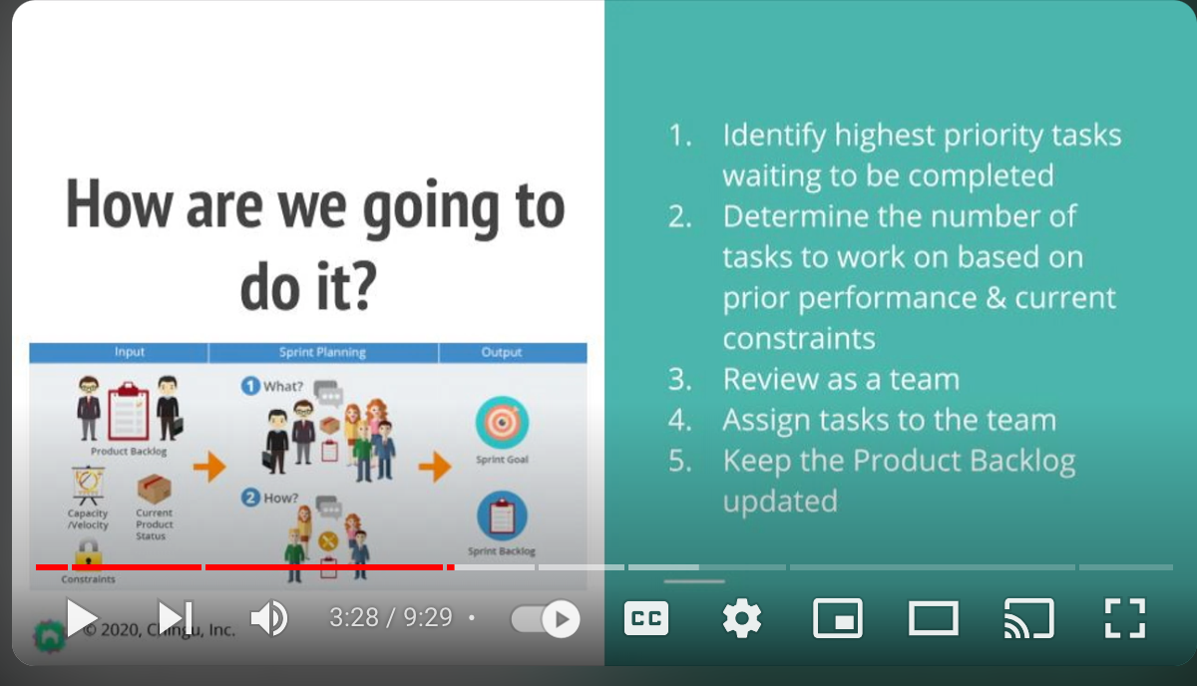Sprint meeting should be held as early in each sprint as possible and last no more than one hour

Identify tasks that can be done by end of current sprint

Each team member works on one task at a time- so higher priority tasks that can be completed during current sprint are done first

When those tasks are completed then team members who are available can work on lower priority tasks

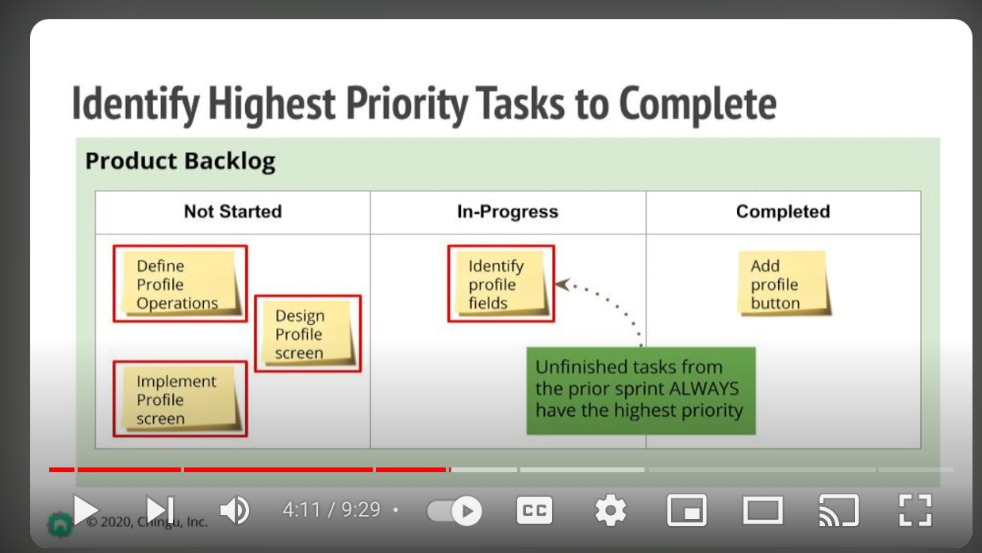

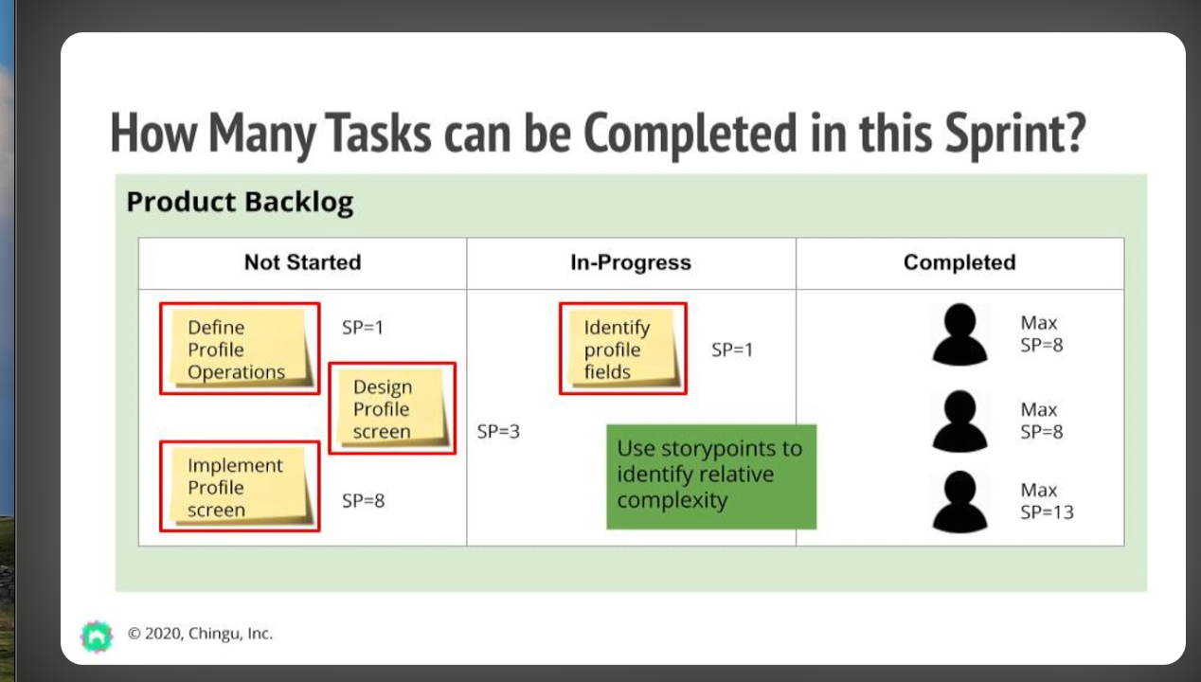

Review and select on what worked and what can be improved

